



September 2021

REPUBLIC OF LESOTHO

**SYSTEM DESIGN & PROTOTYPING DOCUMENT**

**Ministry of Social Development Information & Communication**

Submitted By

Table of Contents

Table of Figures ii

Abbreviations iv

Overview. 1

Use Cases 1

Major Use cases 1

Use Case Diagram 2

Design Overview 3

Software architecture 3

Web Application File Structure 4

Static Content 4

REST API 4

Hardware architecture 5

Server Hardware. 5

Infrastructure 5

Data Design 5

User Interface Design 6

User Login 6

Generic Dashboard 7

Case Capture form 7

Reports 10

QA 11

External Interfaces and Integrations. 11

National Single Registry (NSR) 12

Login 12

Posting a Case 12

SafePal 14

NGBVD 15

Web Information Page 15

Non-Functional Requirements 16

Performance and structural Requirements 16

Design Constraints 16

Approval Form 16

# Table of Figures

Figure 1: Use Case Diagram 3

Figure 2: Infrastructure Map 6

Figure 3: User Login Interface 7

Figure 4: User Generic Dashboard 8

Figure 5: Incoming Call view 8

Figure 6: Follow Up case search form 9

Figure 7: Reporter Details Form 9

Figure 8: Case Form 10

Figure 9:Case Action Form 10

Figure 10: Case Update trail 11

Figure 11:Reports Preview 11

Figure 12:Report Export Formats 12

Figure 13: QA Form 12

# Abbreviations

VAC – Violence Against Children

CRM - Customer Relations Management

REST - Representational State Transfer

API – Application Programming Interface

SIP - Session Initiation Protocol

CRUD - Create, Read, Update and Delete

RAM – Random Access Memory

TB - Terabyte

GB - Gigabyte

GHz – Gigahertz

CPU - Central Processing Unit

QA – Quality Analysis

CSS – Cascading Style Sheets

# Overview.

The System Design Document here describes how the functional and nonfunctional requirements captured in the requirements document transform into more technical system design specifications for the upgrade of the Lesotho Child helpline. It presents a number of different architectural views to depict the different aspects of the system.

This document informs the system development process and gives the development team guidance on the architecture of the system based on the compiled requirements for the Helpline System.

This document in intended both for the project management & development team and the client. With this document, the client can have the solution development progress and prepare for the system delivery. The consultant and its team is guided by the architecture and designs defined in this document.

# Use Cases

## Major Use cases

The purpose of the use-case view is to give additional context surrounding the usage of the system and the interactions between its components. For the purposes of this document, each component is considered a use-case actor. The table below lists the actors and gives a brief description of each in the overall use case context of the system.

|  |  |  |
| --- | --- | --- |
| 1. | Client | The client contacts the helpline through the following Medium:  Call  **Call Termination Outcomes**   1. Client Requests for Support => Agents picks and Responds 2. The Hotline is busy =>A message of wait is sent to a client 3. The call fails due to Network Failure => Please Dial Again   Description of Outcomes  #1 The client did not get what they wanted  #2 The hotline is busy message displayed  #3 Network Failures occur during operation Termination/Cancellation of call. |
| 2. | Counsellor | The Agent Receives Calls for request of information or case report from the client.  **Termination Outcomes**   1. Call Rings Via Popup => Counsellor picks and Responds 2. Issue requires Escalation => Counsellor Escalates to respective Supervisor 3. Issue can be Resolved => Counsellor Provides Solution |
| 3. | Supervisors | The Supervisor Receives Escalation Notification from the Counsellor.  The supervisor Appraises Counsellors.  **Termination Outcomes**   1. Notification Received => Supervisor Solves or Escalates 2. Appraises Counsellor => Submit Appraisal Feedback to Counsellor. |
| 4. | Administrator | 1. Manage system users. 2. Manage system configurations. |

## Use Case Diagram

The most common use-cases are outlined and illustrated using UML use-case diagrams and sequence diagrams to clarify the interactions between components.

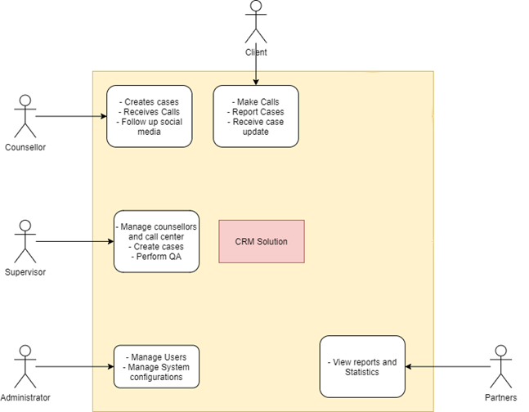

Figure : Use Case Diagram

# Design Overview

## Software architecture

The Solution follows the JAMStack architecture pattern (https://en.wikipedia.org/wiki/Jamstack), which provides the following advantages:

1. Decouples the front-end from the backend - this is achieved by generating the User Interface (UI) on the Client-Side side using JavaScript (instead of generating the UI on the Server-Side)
2. Leverages use of Static Templates to generate the front-end
3. Enables development of a single REST API specification for use by both Web and Android Applications.

The following is an overview of the software stack:

|  |  |
| --- | --- |
| **Component** | **Description** |
| CSS | This contains information on font-color, font-size, padding, margins background-color and borders. This enables the application to have a uniform look and feel though-out all the screens |
| Static Templates | The User Interface screens are defined as Static templates, which are populated at runtime. |
| Rendering Engine | The Rendering Engine evaluates the REST API response and then generates the User Interface using the relevant Static Template |
| SIP.js WebRTC Phone | This provides a virtual phone that can be used to make and receive calls |
| Nginx Web Server | This provides the HTTP/S Gateway to the REST API |
| REST API | This provides a set of CRUD (Create, Read, Update, Delete) URL endpoints. Each CRUD is mapped to a single database table |
| Database | This is the persistent store of application data |

## Web Application File Structure

The Web Application is hosted on the Nginx server and it serves 2 purposes:

1. Delivery of static content (templates, CSS, JS rendering engine and WebRTC Sip client) that comprises the Single Page Web application.
2. REST API

Both the Static Content and REST API are contained in a single folder named **helpline.** The following is file structure of the helpline folder:

### Static Content

/helpline/index.php (Single Page Application Entry Point)

/helpline/js/sip-0.20.0.js (WebRTC SIP client)

/helpline/js/*.js (User Interface rendering engine)

/helpline/app/*.js (User Interface static templates)

### REST API

/helpline/api/index.php (REST API entry point)

/helpline/api/session.php (Session Management Engine)

/helpline/api/rest.php (REST API engine)

/helpline/api/model.php (CRUD endpoints definitions)

The application is customized mainly by editing files in following 2 locations to implement screens and CRUD logic:

1. /helpline/app/*.js (Front End Screens)
2. /helpline/api/model.php (CRUD Logic)

## Hardware architecture

These are the minimum hardware requirement for optimum operation of the solution. It also takes into consideration the different infrastructural components necessary for the functioning of the call center in general.

### Server Hardware.

These are the minimum hardware requirements for the server running the call center CRM, database and call modules.

#### RAM

* Asterisk - 4GB RAM
* Database - 16 GB RAM

#### Storage (HDD/SSD)

* Operating system partition - 100 GB
* Database 100 GB
* Call Recording 1 TB

CPU

* 4 cores each core 2.0 GHz

### Infrastructure

These is a complete hardware infrastructural mapping of the call center. It includes terminations by telecom service providers, power provision & backup and network configuration.

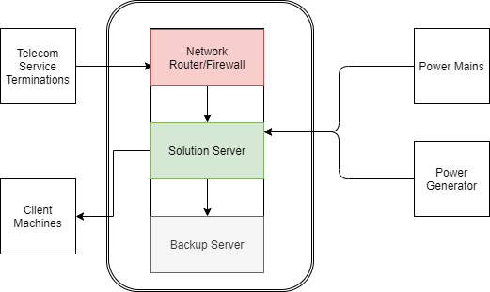

Figure : Infrastructure Map

## Data Design

|  |  |
| --- | --- |
| TABLE NAME | DESCRIPTION |
| session | This holds information on the active sessions |
| Auth | This identifies a user in the system |
| Contacts | This stores information about a person. The following tables have the contact_id foreign key:  auth, reporter, client, perpetrator |
| Case | This identifies a unique case in the system and its current status |
| Activity | This keeps an audit trail of case |
| Reporter | This identifies the person who reported the case |
| Client | This identifies the victim(s) in the case |
| Perpetrator | This identifies the offender(s) in a case |
| Call | This stores call information, such as datetime, phone number, extension, wait-time, talk-time, hangup-status |
| Category | This holds the definition of various enumerated types used in the case form. For example: age-group, gender, location, case-status, etc |
| QA | This holds results of a quality-assessment evaluation |

## User Interface Design

This is a presentation of the user interface of the solution as designed or as shall be designed in line with the user levels, processes and logical data flows.

Some of the major parts of the system interfaces are as listed below:

### User Login

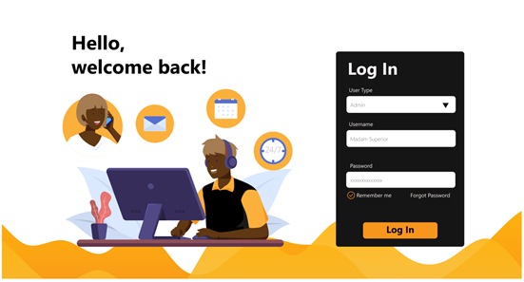

Figure : User Login Interface

### Generic Dashboard

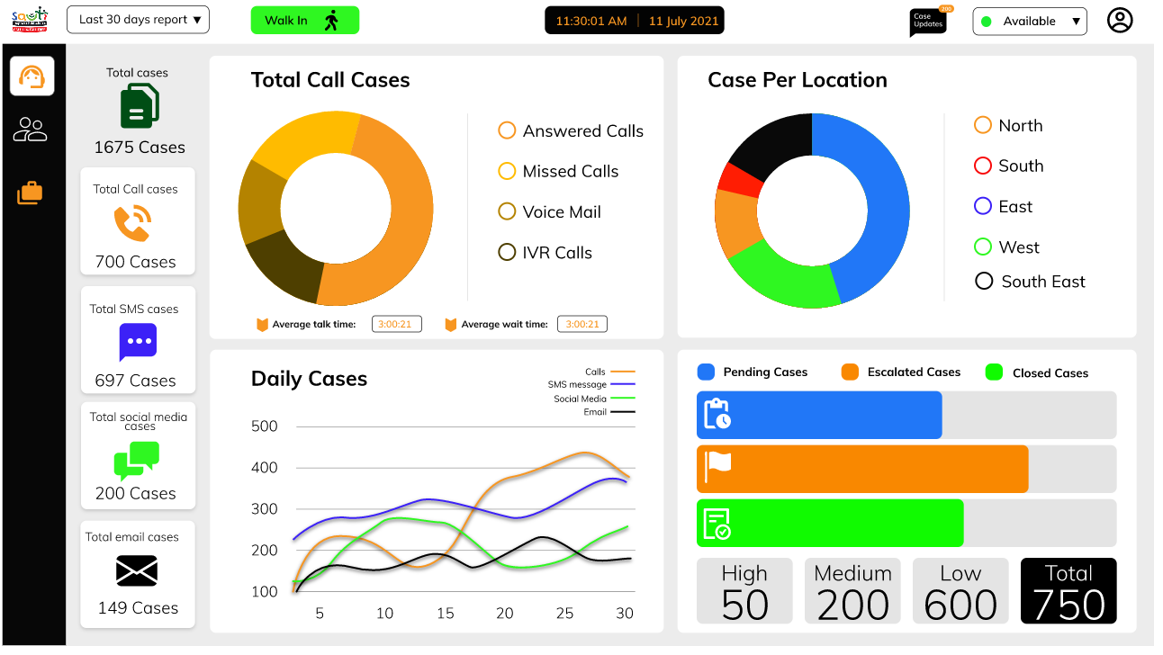

Figure : User Generic Dashboard

### Case Capture form

#### Incoming Call

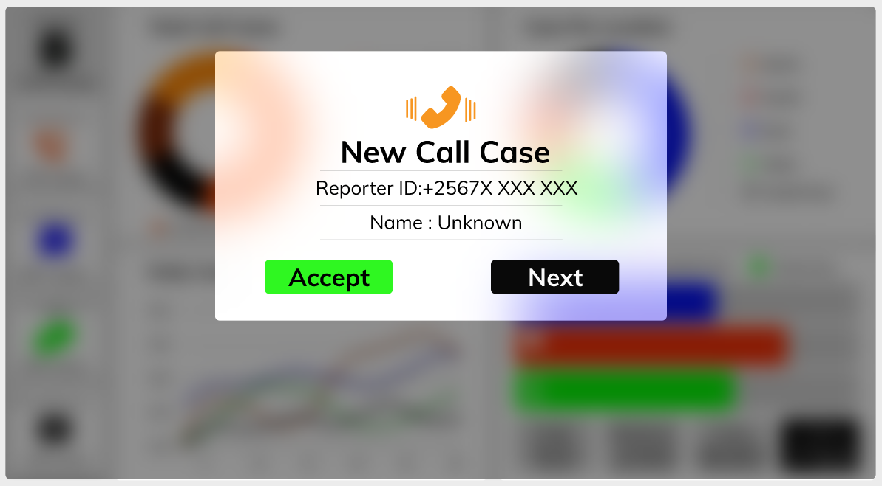

Figure : Incoming Call view

#### Follow Up Case Search

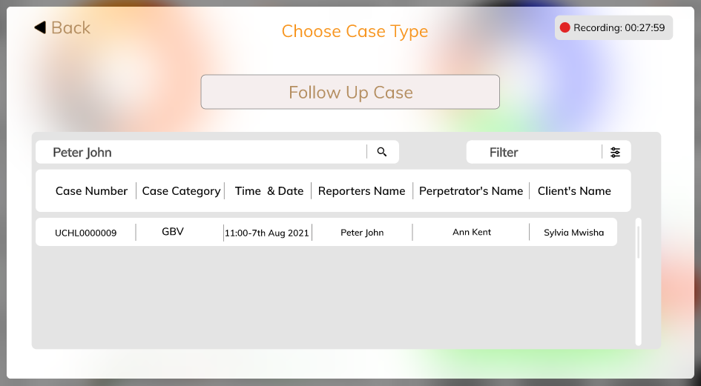

Figure : Follow Up case search form

#### Reporter Details

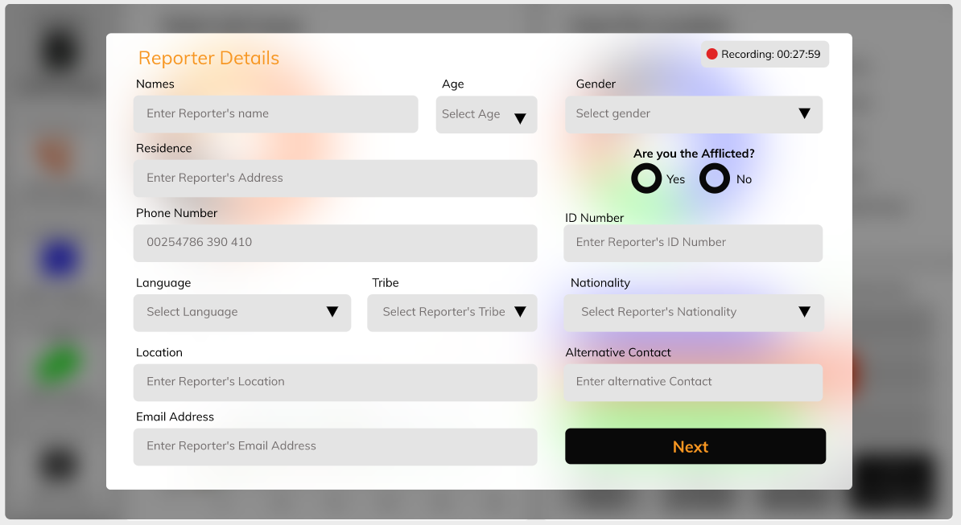

Figure : Reporter Details Form

#### Case Details

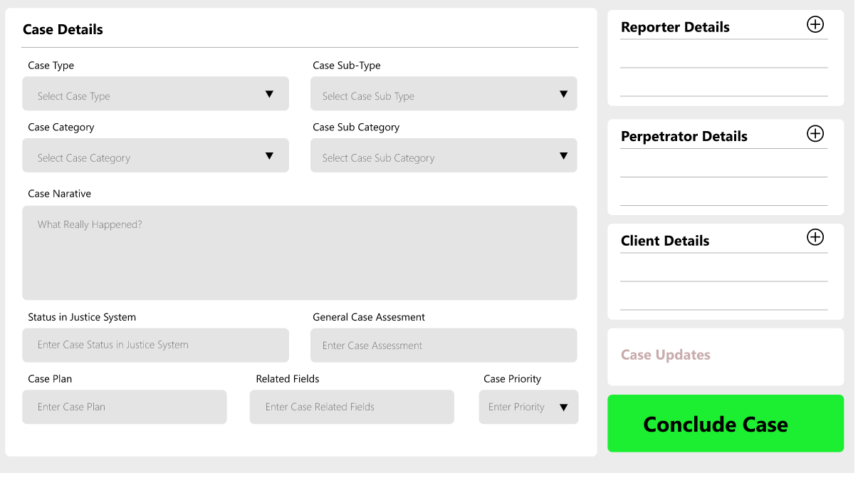

Figure : Case Form

#### Case Submission

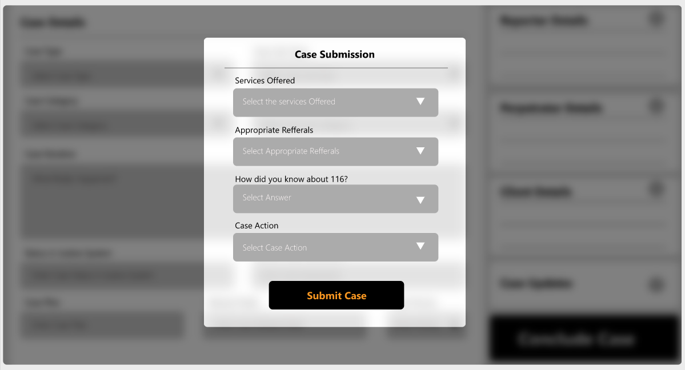

Figure :Case Action Form

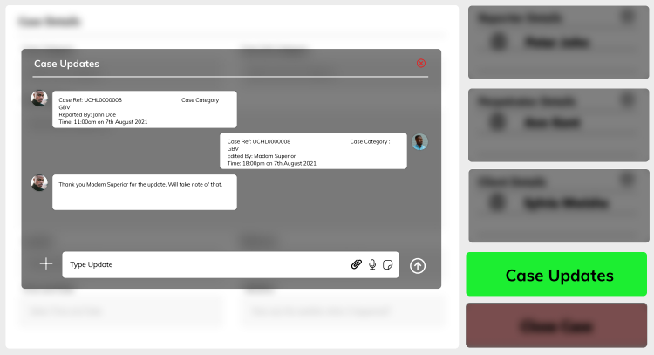

Figure : Case Update trail

### Reports

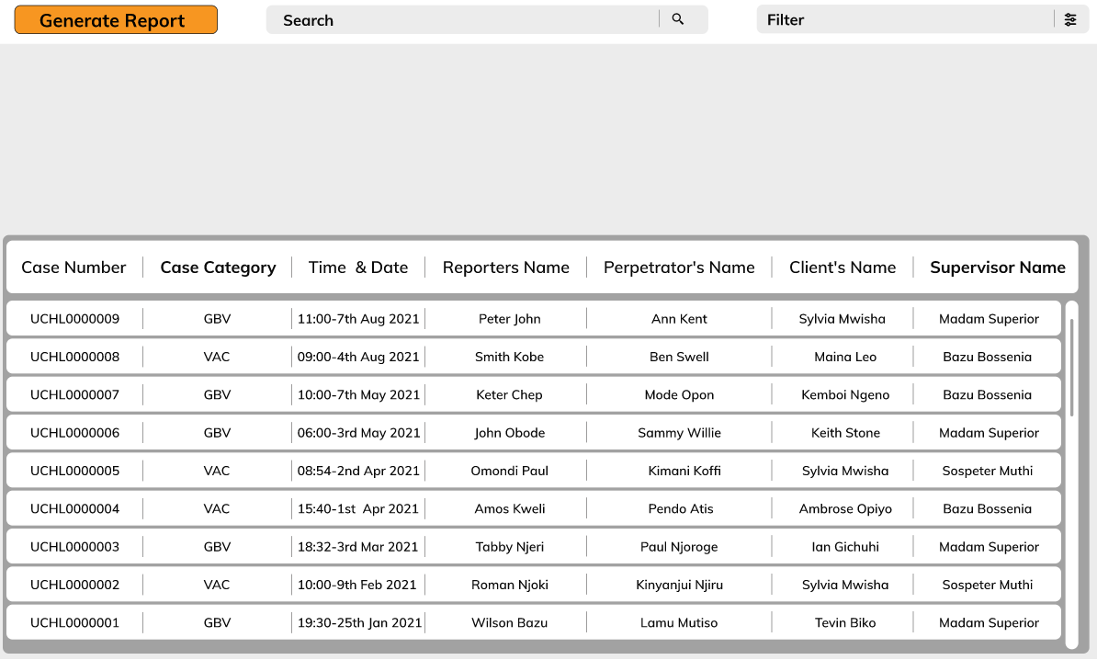

Figure :Reports Preview

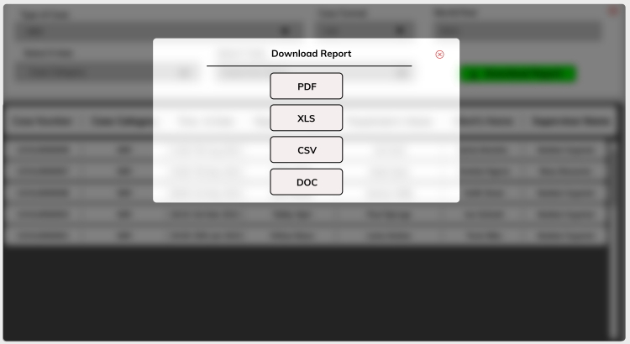

Figure :Report Export Formats

### QA

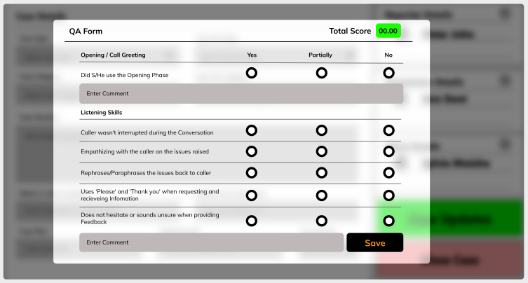

Figure : QA Form

# External Interfaces and Integrations.

The helpline shall have custom integrations to external systems to share data in different ways. It shall also have a universal API for querying cases with different parameters as defined in the requirement specification.

# Non-Functional Requirements

## Performance and structural Requirements

The solution shall not limit the number of concurrent user access only to the extent of the system resource capacity which shall be considered during the development and deployment process.

The solution shall design and implement security protocols for call and case data having in mind data confidentiality in remote backup, restore and recovery plans, procedures and systems.

The hosting platform shall have deployed enhancements and Secure Sockets Layer (SSL) certificate for added security.

The system shall not be limited to in-office users but also accessible via VPN for remote working.

## Design Constraints

The software solution shall take advantage of and be developed on open source technologies, tools and standards.

# Approval Form

|  |  |
| --- | --- |
| By signing this document, I acknowledge that I have received stated deliverables to the agreed quality levels. | |
|  | **Signature:** |
| **Date:** |
|  | **Signature:** |
| **Date:** |
|  | **Signature:** |
|  | **Date:** |